Project Scope:
The project scope was implementing a trust-based framework that detects malicious updates in IDS-based data.

Project Objective:
The project objective of this project was a test of the skills learned overall in this research project as well as a definitive strategy for dealing with a major problem, issues with bad data, facing federated learning algorithms.

Dataset Used:
All datasets used were taken from this Network Intrusion dataset from 2017 of a week of recorded activity involving attacks. The dataset used was from Wednesday as it had both benign and malicious examples, allowing a test of both types of bad data.

Malicious Method Used:
The malicious methods used:
- Gaussian Noise, which
- Extreme Scaling, which

Defenses Used:
The malicious methods were blocked by a combination of:
- Dynamic Krum, which is the main method the defensive network uses to prevent malicious attackers. It calculates Euclidean distances between all clients; if there’s an outlier, it’s likely Gaussian Noise or a malicious client. It then will reduce said malicious client’s score to reduce its overall trust.
- Reputation Threshold Filtering, which works in tandem with Dynamic Krum to blacklist low-trust clients if they repeatedly fail the Dynamic Krum testing.
- Updated Norm Clipping, which neutralizes extreme scaling attacks by calculating each client’s Euclidean norm.
- Reputation-Weighted Aggregation, which multiplies sample count by reputation score rather than by data sample size. This makes sure that the trusted clients have the most influence over the global model.

Results and Statistics:
- Results of Gaussian Noise:
- 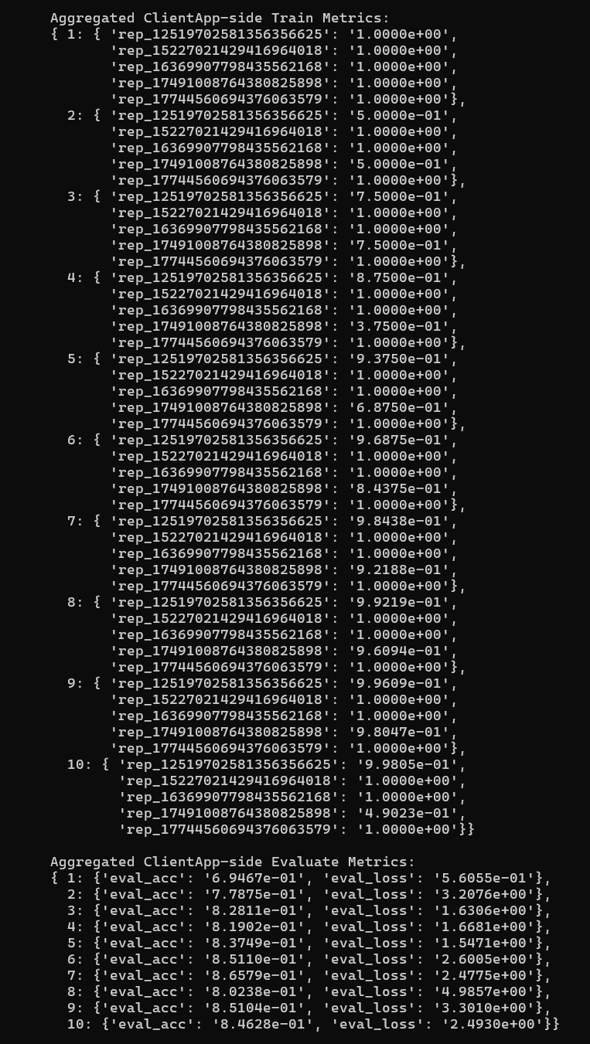
- Results of Extreme Scaling:
- 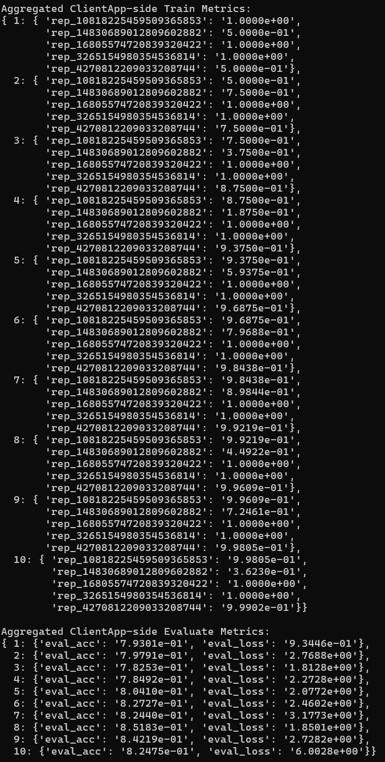
Problems Encountered:
The problems encountered were few and far between.

